AI-Driven Detection Of Labour Law Gaps Causing Wage Inefficiencies Across Indian Industries

Preeti Ambwani
School of Computer Science and Engineering (SCOPE)
Vellore Institute of Technology, Vellore
Vellore, India
ambwanipreeti@gmail.com

Shreeya Srivastava
School of Computer Science and Engineering (SCOPE)
Vellore Institute of Technology, Vellore
Vellore, India
intelshreeya25@gmail.com

Abstract— Wage Inequalities in Indian industries is driven by complex interactions among skill, experience, industry norms, regional factors and weak enforcement of labor laws, which traditional models often fail to capture. This project proposes an AI-driven system using classical, ensemble and exploratory Quantum ML techniques to detect wage inefficiencies and predict fair compensation. Data is collected and preprocessed from multiple sources, with ensemble models like Random Forest and Gradient Boosting improving accuracy over baseline methods, while explainable AI provides insights into key factors behind wage disparities. Experimental results show strong performance of ensemble models and potential of QML in handling complex patterns, culminating in a web-based decision-support tool for policymakers and stakeholders to enable fair, data-driven wage patterns
Keywords—Wage Gap Detection, Machine Learning, Quantum Machine Learning, Explainable I, Fair Wage Prediction, Labor Economics

Introduction
Wage disparities are a significant concern in India’s labour-intensive industries such as construction, textiles and manufacturing. These disparities arise due to a combination of socio-economic factors, regulatory inefficiencies and weak enforcement of wage policies. Traditional wage auditing methods rely heavily on manual inspections and grievance-based systems, which are time-consuming, reactive and difficult to scale.
Recent advancements in AI provide new opportunities to automate wage analysis and identify compensation gaps. However, classical machine learning models often struggle to capture complex relationships between multiple socio-economic variables, additionally, black-box models lack interpretability, limiting their usability in policy-making.
This paper proposes an AI-based wage gap detection system that integrates classical machine learning and Quantum Machine Learning (QML) techniques. The system aims to improve prediction accuracy, enhance interpretability and provide actionable insights for fair wage assessment. A full-stack implementation is developed to enable real-time analysis through a web-based interface.

Literature Review
Previous research highlights that wage disparities in developing economies are slightly influenced by enforcement rather than legislation alone. Studies indicate widespread noncompliance with minimum wage laws and strong segmentation between formal and informal sectors. Machine learning techniques have been increasingly applied in economic analysis to improve prediction accuracy and uncover hidden patterns.
However, existing approaches face several limitations, including lack of interpretability, bias in historical data and absence of enforcement-related variables. Recent advancements in explainable AI address some of these challenges by improving model transparency. Additionally, emerging research in Quantum Machine Learning explores the potential of quantum circuits to capture complex data relationships beyond classical capabilities.
Despite these developments, there remains a gap in integrating predictive models with scalable deployment systems for real-time wage analysis.

Methodology
The proposed system follows a modular architecture consisting of data processing, model development and deployment components.

System Architecture
The proposed system follows a layered architecture designed to support efficient wage analysis and prediction across Indian industries. At the top level, the presentation layer provides a web-based interface through which users can input worker details and visualize results. The application layer manages user requests and coordinates communication between the frontend and backend components through API calls.
The data processing layer prepares input data by handling missing values, encoding categorical variables, and normalizing features to ensure consistency. The processed data is then passed to the model layer, which includes baseline machine learning models, ensemble methods such as Random Forest and Gradient Boosting, and an exploratory hybrid quantum-classical model for advanced pattern recognition.
To improve transparency, an explainability component is integrated to identify key factors influencing wage predictions and highlight contributors to wage disparities. Finally, the output is presented through a visualization module that displays wage predictions, underpayment detection, and analytical insights. This architecture ensures scalability, interpretability, and effective decision support for labor policy analysis.
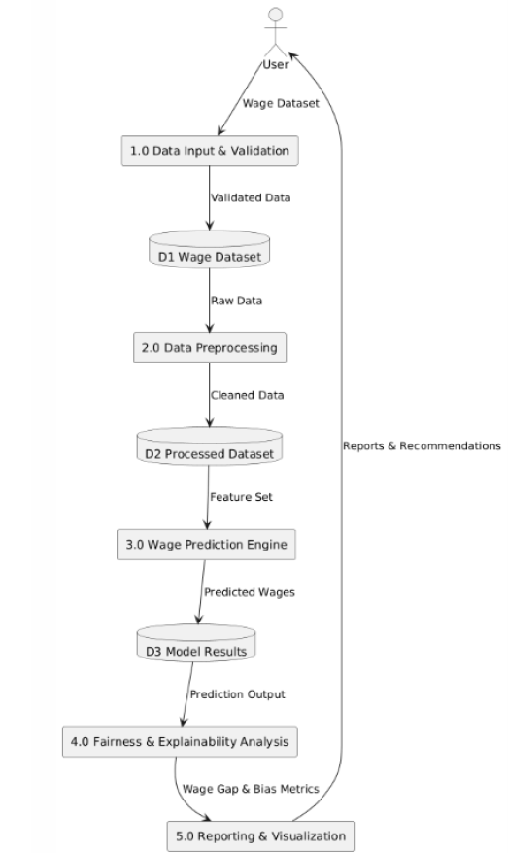
Fig. 1. Data Flow Diagram Level 1

Data Collection and Preprocessing

The dataset includes features such as industry type, job role, experience, skill level, education, region and actual wage. Data preprocessing involves handling missing values, encoding categorical variables and normalising numerical features. The dataset includes 15 Indian states (Maharashtra, Tamil Nadu, Uttar Pradesh, etc.) and 15 industries such as construction, textiles and agriculture. Wages were synthetically generated using a base formula combining education level and experience, with additional adjustments for gender-based wage disparities and stochastic noise to simulate real-world variability.
Wages were computed as:
Base Wage = Education-based wage + (Experience * 300),
With a 15% penalty applied for female workers to reflect observed labour survey trends.

Model Development
Three categories of models are implemented:
- Baseline Model: Linear Regression for initial benchmarking.
- Ensemble Models: Random Forest and Gradient Boosting for improved performance.
- Quantum Model: Hybrid quantum-classical state the units for each quantity that you use in an equation.
It uses quantum feature encoding and variational circuits to capture non-linear relationships in data.

Evaluation Metrics
Model performance is evaluated using:
- Accuracy
- Precision
- Recall
- F1-score
- ROC-AUC
TABLE I. MODEL COMPARISON
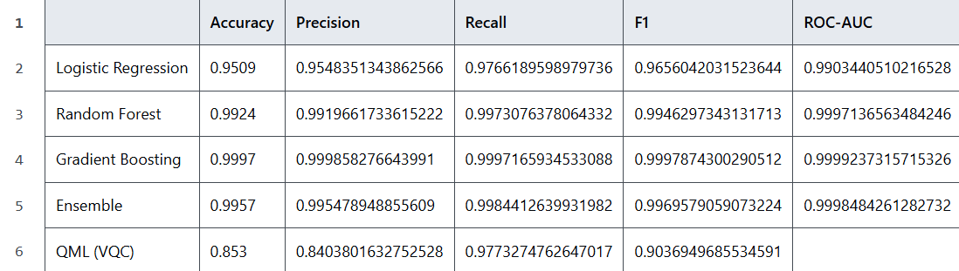
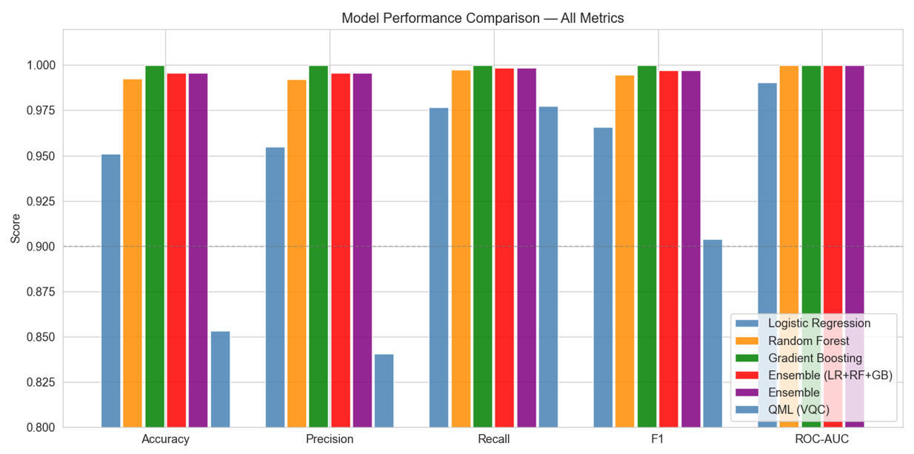
Fig. 2. Model Performance Comparison

System Deployment
The system is deployed using a FastAPI backend and a React frontend. The backend handles prediction requests, while the frontend provides a user-friendly interface for data input and result visualisation.

Results
The experimental results demonstrate that ensemble models outperform baseline models by effectively capturing non-linear relationships in wage data. The Quantum Machine Learning model shows comparable or improved performance in specific scenarios, particularly in identifying complex interactions among features.
Key findings include:-
- Identification of underpaid workers based on predicted fair wages.
- Significant influence of experience, skill level and industry type on wage outcomes.
- Improved interpretability through feature importance analysis.
While QML models offer deeper analytical capabilities, they introduce additional computational overhead due to quantum circuit simulation. However, their ability to model complex patterns highlights their potential for future applications.
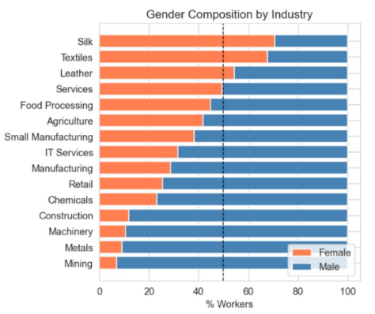
Fig. 3. Gender Wage Gap in Industries

After the VQC classifies workers, K-Means clustering groups them into 4 profiles:
- Gender-Disadvantaged: 78% underpayment rate, 28% workforce
- Low-Wage Informal: 71%underpayment rate, 35% of workforce (largest group)
- Skilled Formal: Only 22% underpayment rate, 18% of workforce
- Low-Skill Contract: 48% underpayment, 19% of workforce
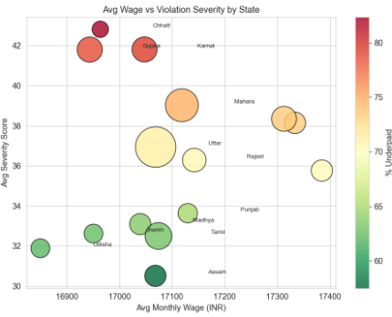
Fig. 4. Age vs Violation severity by state
Feature Importance Analysis:
- Feature importance analysis was performed to identify the key factors influencing wage predictions across different models. The results indicate that actual wage is the most dominant feature, significantly impacting model decisions across both Random Forest and Gradient Boosting models. Secondary features such as education level and state also contribute meaningfully, highlighting the influence of skill and regional disparities on wage outcomes.
- In contrast, features such as industry, experience, and gender exhibit relatively lower importance scores, suggesting that their impact is either indirect or captured through interactions with other variables. The consistency observed across models reinforces the reliability of these findings. This analysis enhances model interpretability and supports the identification of critical factors driving wage inequality, thereby improving the transparency and policy relevance of the proposed system.

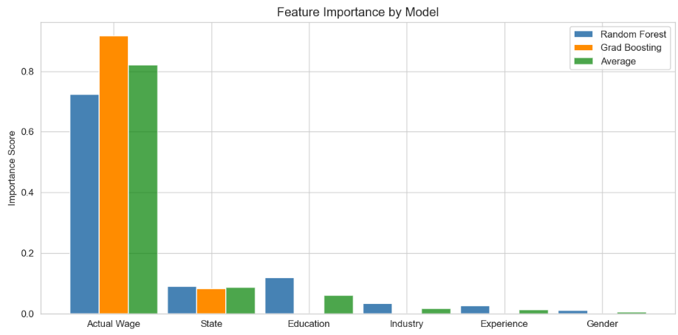
Fig. 5. Feature Importance Comparison

Discussions
The analysis highlights that violations of key labour laws, particularly the Minimum Wages Act, 1948 and Payment of Wages Act, 1936, affect the largest number of workers and contribute to the highest economic losses. Moderate violations are observed under the Equal Remuneration Act, 1976 and POSH Act, 2013, indicating persistent issues related to gender-based pay disparity and workplace discrimination. Lower but notable impacts are seen in laws such as the Contract Labour (Regulation & Abolition) Act, 1970, Building & Construction Workers Act and Agricultural Labour laws, reflecting sector-specific compliance challenges.
The distribution analysis further shows that most workers violate multiple labour laws simultaneously, with the majority falling in the range of 2-3 violations, indicating systemic non-compliance rather than isolated cases. Ensemble models effectively captured these complex patterns, while the Quantum Machine Learning model demonstrated potential in identifying deeper feature interactions across legal and economic variables.
Overall, the results emphasize that wage inefficiencies are strongly linked to legal non-compliance patterns, reinforcing the need for AI-driven, scalable monitoring systems for effective labour policy enforcement.

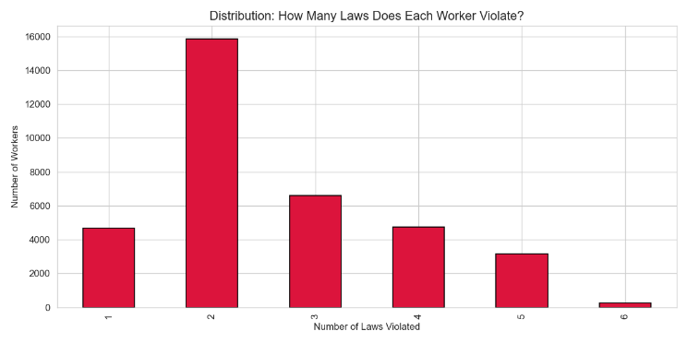
Fig. 6. Laws Violated by Each Worker

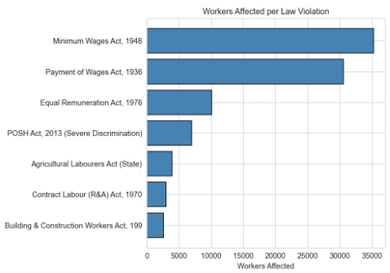
Fig. 10. Workers Affected per Law Violation

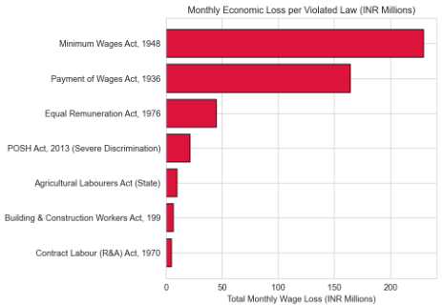
Fig. 11. Monthly Economic Loss due to Law Violations

Conclusion
The study demonstrates that AI-driven models can effectively detect wage inefficiencies across Indian industries, with ensemble methods outperforming baseline approaches in capturing complex wage patterns. The results reveal significant underpayment, affecting over half the workforce, with agriculture and states like Uttar Pradesh showing the highest vulnerability, particularly among low-educated workers. Feature importance analysis highlights that wage disparities are primarily driven by structural factors such as actual wages, education and regional direct roles. The exploratory Quantum Machine Learning model shows potential in modelling complex interactions, reinforcing the value of advanced AI techniques for scalable, transparent and data-driven wage analysis, with scope for further refinement and real-world deployment.

References

[1]. Acemoglu, D., & Autor, D. (2011). Skills, tasks and technologies: Implications for employment and earnings. Handbook of Labor Economics, 4, 1043-1171.
[2]. Ahsan, A., & Pagés, C. (2009). Are all labor regulations equal? Evidence from Indian manufacturing. Journal of Comparative Economics, 37(1), 62-75.
[3]. Aletras, N., Tsarapatsanis, D., Preoţiuc-Pietro, D., & Lampos, V. (2016). Predicting judicial decisions of the European Court of Human Rights: A Natural Language Processing perspective. PeerJ Computer Science, 2, e93.
[4]. Anand, T., & Khera, R. (2016). Recent trends in Indian wages and inequality. Indian Journal of Labour Economics, 59(3), 321-341.
[5]. Athey, S. (2019). The impact of machine learning on economics. The Economics of Artificial Intelligence: An Agenda, 507-547.
[6]. Athey, S., & Imbens, G. W. (2019). Machine learning methods that economists should know about. Annual Review of Economics, 11, 685-725.
[7]. Basu, A. K., Chau, N. H., & Kanbur, R. (2010). Turning a blind eye: Costly enforcement, credible commitment and minimum wage laws. The Economic Journal, 120(543), 244-269.
[8]. Belloni, A., Chernozhukov, V., & Hansen, C. (2014). High-dimensional methods and inference on structural and treatment effects. Journal of Economic Perspectives, 28(2), 29-50.
[9]. Besley, T., & Burgess, R. (2004). Can labor regulation hinder economic performance? Evidence from India. The Quarterly Journal of Economics, 119(1), 91-134.
[10]. Bhorat, H., Kanbur, R., & Stanwix, B. (2017). Minimum wages in sub-Saharan Africa: A primer. The World Bank Research Observer, 32(1), 21-74.
[11]. Bhorat, H., Lilenstein, K., Oosthuizen, M., & Stanwix, B. (2021). Minimum wage compliance and household welfare: An analysis of over 1500 minimum wages in India. World Development, 147, 1056-1068.
[12]. Breman, J. (2016). At work in the informal economy of India: A perspective from the bottom up. Oxford University Press.
[13]. Cengiz, D., Dube, A., Lindner, A., & Zipperer, B. (2019). The effect of minimum wages on low-wage jobs. The Quarterly Journal of Economics, 134(3), 1405-1454.
[14]. Chalkidis, I., Fergadiotis, M., Malakasiotis, P., Aletras, N., & Androutsopoulos, I. (2020). LEGAL-BERT: The muppets straight out of law school. Findings of the Association for Computational Linguistics: EMNLP 2020, 2898-2904.
[15]. Chatterjee, U., & Kanbur, R. (2015). Non-compliance with the minimum wage law in India: Estimation and determinants. Oxford Development Studies, 43(4), 365-394.
[16]. Chernozhukov, V., Chetverikov, D., Demirer, M., Duflo, E., Hansen, C., Newey, W., & Robins, J. (2018). Double/debiased machine learning for treatment and structural parameters. The Econometrics Journal, 21(1), C1-C68.
[17]. Clemens, J., & Strain, M. R. (2020). Understanding "Wage Theft": Evasion and avoidance responses to minimum wage increases. IZA Discussion Papers, 12167.
[18]. Dube, A., Lester, T. W., & Reich, M. (2010). Minimum wage effects across state borders: Estimates using contiguous counties. The Review of Economics and Statistics, 92(4), 945-964.
[19]. Galvin, D. J. (2016). Deterring wage theft: Alt-labor, state politics, and the policy gap. Perspectives on Politics, 14(2), 324-350.
[20]. Gudibande, R. R., & Jacob, A. (2018). Minimum wages for domestic workers: Impact evaluation of the Indian experience. GLO Discussion Paper, 294.
[21]. Harriss-White, B. (2006). India working: Essays on society and economy. Cambridge University Press.
[22]. Hendrycks, D., Burns, C., Chen, A., & Ball, S. (2021). CUAD: Contract understanding atticus dataset. NeurIPS Datasets and Benchmarks Track.
[23]. Imbert, C., & Papp, J. (2015). Labor market effects of social programs: Evidence from India's employment guarantee. American Economic Journal: Applied Economics, 7(2), 233-263.
[24]. Jha, P., & Golder, S. (2008). Labour market regulation and economic performance: A critical review of arguments and some plausible lessons for India. Economic and Political Weekly, 43(1), 91-100.
[25]. Kalamkar, P., Venugopalan, J., & Raghavan, V. (2021). Indian Legal NLP benchmarks: A survey. JSAI-isAI Workshops.
[26]. Katz, D. M., Bommarito, M. J., & Blackman, J. (2017). A general approach for predicting the behavior of the Supreme Court of the United States. PLoS ONE, 12(4), e0175070.
[27]. Khadar, N. M., & Ali, M. (2025). Concept of 'Wage Theft' in India: Analyses of Internal Labour Migrations and Legal-Institutional Frameworks. International Journal of Law, 6(1), 57-64.
[28]. Kleinberg, J., Ludwig, J., Mullainathan, S., & Sunstein, C. R. (2018). Discrimination in the age of algorithms. Journal of Legal Analysis, 10, 113-174.
[29]. Lundberg, S. M., & Lee, S. I. (2017). A unified approach to interpreting model predictions. Advances in Neural Information Processing Systems, 30.
[30]. Malik, P., et al. (2021). ILDC for CJPE: Indian legal documents corpus for court judgment prediction and explanation. Proceedings of the 59th Annual Meeting of the Association for Computational Linguistics, 4046-4062.
[31]. Manning, A. (2021). The elusive employment effect of the minimum wage. Journal of Economic Perspectives, 35(1), 3-26.
[32]. Menon, N., & Rodgers, Y. V. D. M. (2017). The impact of the minimum wage on male and female employment and earnings in India. Asian Development Review, 34(1), 28-64.
[33]. Mullainathan, S., & Spiess, J. (2017). Machine learning: An applied econometric approach. Journal of Economic Perspectives, 31(2), 87-106.
[34]. Muralidharan, K., Niehaus, P., & Sukhtankar, S. (2023). General equilibrium effects of (improving) public employment programs: Experimental evidence from India. Econometrica, 91(4), 1261-1295.
[35]. NBER. (2024). Minimum Wages in the 21st Century. NBER Working Paper Series, 32878.
[36]. OECD. (2025). AI in policy evaluation: Governing with Artificial Intelligence. OECD Publishing.
[37]. Paul, S., Goyal, P., & Ghosh, S. (2022). Pre-trained language models for the Indian legal domain. Proceedings of the 13th International Conference on Natural Language Processing.
[38]. Rani, U., Belser, P., Oelz, M., & Ranjbar, S. (2013). Minimum wage coverage and compliance in developing countries. International Labour Review, 152(3-4), 381-410.
[39]. Ravi, S. (2021). The Code on Wages, 2019: An Analysis. SSRN Electronic Journal, 3788221.
[40]. Ronconi, L. (2010). Enforcement and compliance with labour regulations in Argentina. Industrial and Labor Relations Review, 63(4), 719-736.
[41]. Roychowdhury, P. (2019). Visible vs. invisible violations: Minimum wage non-compliance in India. World Development, 116, 28-41.
[42]. Sen, K., & Das, K. (2016). Where have all the workers gone? Puzzles of weak labour absorption in Indian manufacturing. Asian Development Review, 33(2), 1-33.
[43]. Sharma, A. (2016). Flexibilization of Indian labour market: Empirical evidence from neo-liberal era. International Journal of Social Economics, 43(10), 1036-1052.
[44]. Shur-Ofry, M. (2023). Multiplicity as an AI Governance Principle. SSRN Working Paper, 4444354.
[45]. Soundararajan, V. (2013). Minimum wages and enforcement in India. IZA Discussion Paper Series, No. 7480.
[46]. Soundararajan, V. (2019). Heterogeneous effects of imperfectly enforced minimum wages in India. Journal of Development Economics, 140, 355-374.
[47]. Srinivasan, T. N. (2010). Employment and India's labor laws. Journal of Comparative Economics, 38(3), 322-341.
[48]. Strittmatter, A. (2025). Machine learning for causal inference in economics. IZA World of Labor, 516.
[49]. Sundar, K. R. S. (2015). Industrial conflict in India in the post-reform period. Indian Journal of Labour Economics, 58(3), 343-365.
[50]. Surie, A., & Sharma, D. (2019). Climate change, Agrarian distress, and the role of digital labour platforms: Evidence from Bengaluru, India. Review of Agrarian Studies, 9(2).
[51]. Unni, J. (2017). Wage structure and wage differentials in formal and informal sectors in India. The Indian Journal of Labour Economics, 60(3), 393-414.
[52]. Varkkey, B., & Korde, R. (2013). Gender pay gap in the formal sector: 2006–2013. WageIndicator Foundation Data Report.
[53]. Wager, S., & Athey, S. (2018). Estimation and inference of heterogeneous treatment effects using random forests. Journal of the American Statistical Association, 113(523), 1228-1242.
[54]. Weil, D. (2010). Improving workplace conditions through strategic enforcement. Report to the Wage and Hour Division.
[55]. Weil, D. (2018). Creating a strategic enforcement approach to address wage theft: One academic’s journey in organizational change. Journal of Industrial Relations, 60(3), 437-460.
[56]. World Bank. (2018). India Development Update: India’s Growth Story. World Bank Group.
[57]. Zhong, H., Xiao, C., Tu, C., Zhang, T., Liu, Z., & Sun, M. (2020). How does NLP benefit legal system: A summary of legal artificial intelligence. Proceedings of the 58th Annual Meeting of the Association for Computational Linguistics, 5218-5230.
[58]. Zimring, F. E. (2014). The unexamined death of men in India: Violence against women in international perspective. Asian Journal of Criminology, 9(2), 129-143.

